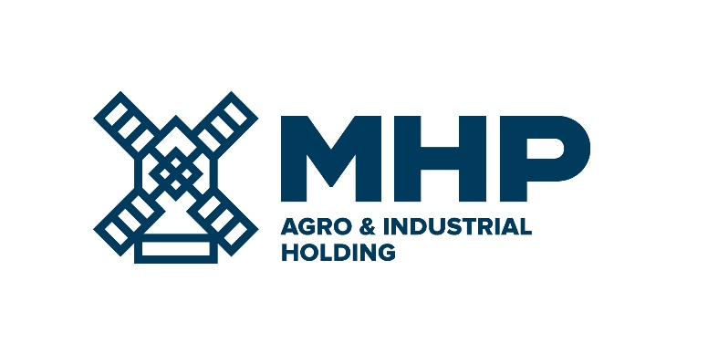
18 June 2018, Limassol, Cyprus

MHP SE
Results of AGM

MHP SE (LSE: MHPC), the parent company of a leading international agro-industrial group with headquarters in Ukraine, focusing primarily on the production of poultry and cultivation of grain, as well as other agricultural operations (meat processing and meat products ready for consumption) today announces that at its Annual General Meeting of shareholders (“Meeting”), 16-18, Zinas Kanther Street, Ayia Triada, 3035 Limassol, Cyprus on the 18th day of June 2018 at 10.00 a.m.all resolutions were adopted as Ordinary Resolutions.

The agenda of the Meeting was as follows:
- the Annual Report of MHP SE for the year end 2017, containing the consolidated management report of the Board of Directors of the Company, the independent auditors report on the audit of the consolidated financial statements of MHP SE and its subsidiaries for the year end 2017 and the consolidated financial statements of MHP SE and its subsidiaries for the year end 2017;

- the report of the independent auditors of the Company and the Audited Financial Statements of the Company for the year end 31 December 2017;

- the transfer of the entire amount lying in the “legal reserve account”, appearing in the equity section of the statement of financial position in the Audited Financial Statements of the Company for the year end 31 December 2017, to the retained earnings, with effect from the date of the AGM (see Explanatory Note below);

- the adoption of new corporate governance code of the Company;

- the adoption of new share dealing code of the Company;

- the re-election as Directors of John Clifford Rich, Yuriy Kosyuk, Victoriya B. Kapelushna, Yuriy Melnyk, John Grant and Raymond William Richards;

- the appointment of Mr. Roberto Banfi as an additional Director of the Company;

- the increase to the remuneration of Mr. Yuriy Kosyuk as CEO of the Company, on the recommendation of the Nomination and Remuneration Committee; and

- the re-appoint Deloitte Limited, the retiring auditors of the Company, as Auditors of the Company until the conclusion of the Annual General Meeting of the Company to be held in the year 2019 and to authorise the Directors to determine their remuneration.

-Ends-

For Investor Relations enquiries  Anastasiia Sobotiuk (Kyiv) | Kyiv: +38 044 207 99 58  a.sobotyuk@mhp.com.ua

